BONES and STONES
a choreographic narrative
by Claudia Bosse

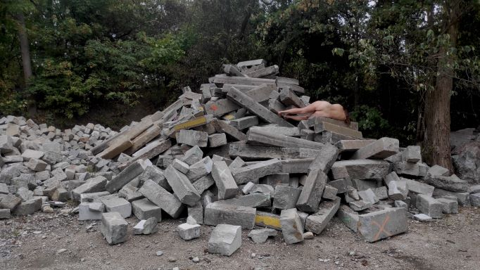

Premiere: 23. february 2023, 07:30pm
Shows: 24./ 25. february 2023, 07:30pm
Halle G Tanzquartier
Museumsplatz 1, Vienna

After the show on 24.02 there will be an artist talk with Claudia Bosse.

Talk: Stage + Material
24. february 2023, 06:30pm
Halle G Tanzquartier
Museumsplatz 1, Vienna

With BONES and STONES, artist Claudia Bosse transforms Hall G into a walk-in landscape. She creates space for the memories of stones, for the memories of bones, for the decay of hybrid bodies and for poetic interweavings with solids, dust, skin, sound and rubble.The earth exhales, in the aftershock we sense connections and wonder about the fragility of our bodies.

In the choreographic narrative BONES and STONES, dancers of different ages dig back through the sediments in time, layer by layer, turning the inside of the earth outside while wearing bones on their skin. Bones that have emerged from matter, older than our universe. Thus, the space becomes a place of encounter and meeting of organic and inorganic material, a place of processes of transformation and poetic intertwining in an electro-acoustic environment by Günther Auer. Are there utopias of communion with the elements? Are there utopias in the assembly of all times?

hybrid beings
entangled in forces
appear
they are shifting matter they are shifted matter
they are speculating about crystallisation of time
about becoming of the earth about kinship
they are recombining knowledge
between matters
spread out in time
movements of monsters …
we carry inorganic matter in our bones
memory of stones
in us

Investigations into post-anthropocentric ecology have long been inscribed in the work of Claudia Bosse and theatercombinat. In 2022, once again awarded a four-year concept grant by the City of Vienna, the cycle ORGAN/ismus – poetics of relation negotiates possible relations between bodies, matter, living beings, organisms, structures and spaces. Most recently, after performances at Impulstanz, Claudia Bosse showed her solo ORACLE and SACRIFICE at the Leberan Festival in Jakarta as well as at ON STAGE in Surakarta and visited various volcanoes in Indonesia. In early summer 2022, she transferred sacrifices and rituals, mythologies and knowledge of nature to the Vienna Prater with ORACLE and SACRIFICE in the woods, inviting people to encounter the non-human. BONES and STONES picks up here, leading into the bodies and into the earth, and will move out of the stage space into the landscape in the summer of 2023.

Claudia Bosse lives in Vienna and Berlin, is a director, choreographer, artist and directs theatercombinat. Her works negotiate forms of violence, history and concrete utopias. She understands her expansive choreographies as "art of a temporary community" - also with non-human beings - in which she interweaves myths, rituals, texts and documents with bodies, language, objects and choirs to create pieces. Inside and outside Europe, in museums, architectures, theaters, landscapes and urban spaces, she develops site-specific works and interventions.

She is currently working on the four-year project ORGAN/ismus - poetics of relations, TPA translocal performative academy for space related performative practice between Europe and Southeast Asia, and PUBLIC PERFORMANCE SCHOOL in Vienna.
Most recently: commune 1-73 with 73 fragments on the Paris Commune of 1871, FFT Düsseldorf, ORACLE and SACRIFICE in the woods, with Brut Wien in the Vienna Prater, ORACLE and SACRIFICE 1 or the evacuation of the present for Taman Ismail Marzuki Art Center as part of LEBARAN Festival Jakarta, Studio Plesungan in Surakarta, Impulstanz Vienna, Pumpenhaus Münster, at TQW and FFT Düsseldorf, the last IDEAL PARADISE in Jakarta, which was also shown at the German Dance Platform in Essen.

theatercombinat is a nomadic production organism for internationally produced independent art and theater works under the direction of artist and choreographer Claudia Bosse. theatercombinat works within and outside Europe on site-specific collaborations with various institutions, initiatives and artists.
www.theatercombinat.com

Credits BONES and STONES
concept/ choreography/ space/ text: Claudia Bosse; sound: Günther Auer; performance/ choreography: Anna Biczók, Myrthe Bokelmann, Anita Kaya, Christa Zuna Kratky, Marcela San Pedro, Carla Rihl; light: Paul Grilj; assistance: Larry Mey; outside eye: Astrid Kaminski, Julia Zastava; consulting: Mathias Harzhauser, Gerlinde Gruber, Barbara Imhof; helping hands: Ines Kaiser, Florian Berger communication: Michael Walk; production: Dagmar Tröstler.

A theatercombinat production. Co-produced by Tanzquartier Wien. In cooperation with the Natural History Museum (NHM) Vienna. Supported by the Municipal Department of Cultural Affairs, Vienna, and the Austrian Federal Ministry for Arts, Culture, the Civil Service and Sport. Research residency at Studio Plesungan, Surakarta, Indonesia. Thanks to the NHM for the loans and the liquifer systems group, Peter Stamer, Krassimira Kruschkova and Marco Tölzer.

