BONES and STONES in the landscape
by Claudia Bosse

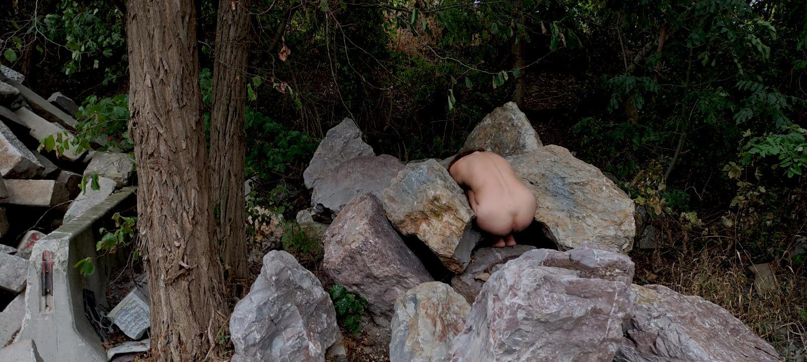
Foto: Günther Auer/ Claudia Bosse
Premiere 9. September 2023, 19:00
Show 10. September 2023 18:00
Further Version 16. September 2023, 17:00
Symposion Lindabrunn
Steinbruchstrasse 25
2551 Enzesfeld-Lindabrunn

BONES and STONES in the landscape
Conzept/ Choreography/ Space: Claudia Bosse;
Live Sound: Günther Auer;
Performance/ Choreography: Anna Biczok, Myrthe Bokelmann, Anita Kaya, Christa Zuna Kratky, Marcela San Pedro, Carla Rihl;
Assistance: Larry Mey; Consultancy: Mathias Harzhauser, Gerlinde Gruber, Barbara Imhof; Communication: Laura Stöckler;
Production: Dagmar Tröstler.
A production by theatercombinat in co-production with Tanzquartier Wien and FFT Düsseldorf. In cooperation with theatercombinat in Koproduktion Naturhistorisches Museum Wien (NHM) and Symposion Lindabrunn. Supported by the Kulturabteilung der Stadt Wien, the Bundesministerium für Kunst, Kultur, öffentlichen Dienst und Sport, and the Province of Lower Austria Research-Residency at Studio Plesungan, Surakarta, Indonesien.

See the stars, the grass, the pores on the skin and the erosion of stones
In BONES and STONES in the landscape, the artist and choreographer Claudia Bosse, together with six performers of different ages, digs into time, into the formation of our planet and penetrates its layers and sediments. In search of the memory of the stones, the performers move through the landscape of the Symposion Lindabrunn, located in Lower Austria, creating poetic interweavings with matter, dust, sound and rubble.
BONES and STONES is a game with associations,
a multidimensional utopia.
Rando Heinemann, Tanz.at
BONES and STONES in the landscape establishes another chapter of theatre in the landscape. Based on BONES and STONES at Tanzquartier Wien, the latest work by Nestroy Prize winner Claudia Bosse, who has worked in and outside of Europe, unfolds as a choreographic environment under the open skies. Hybrid bodies move through the spacious arena in live sounds by Günther Auer. Bare stones meet bare skin, animated matter meets cosmic dust. Everything solid is in motion and in an intimate exchange with the organic an inorganic material surrounding us. We share our bodies with organisms, viruses, bacteria; share our ever-renewing bones with dust from other solar systems.
Do utopias of community with the elements exist? The recently published monograph Claudia Bosse - kein Theater. Alles möglich! in the series postdramatic theatre in portraits of the Berlin Alexander Verlag gives an insight into the artistic work of the “high-flyer of the Viennese performance scene” (Helmut Ploebst, Der Standard) with theatercombinat before and up to her search for an artistic practice that include other species and non-human actors.
A rethinking based on post-anthropocenic ecology has been essential for the work of Claudia Bosse for several years. As part of the work cycle Umdenken ORGAN/ismus – poetics of relations, which is made possible by a 4-year concept funding (2022-2025) by the City of Vienna, Claudia Bosse invites with BONES and STONES in the landscape to a walk through times and sediments, to a gathering of matter, organisms, bodies and time/s.
Most recently, after performances at Impulstanz and Tanzquartier Wien, Claudia Bosse showed her solo ORACLE and SACRIFICE oder die evakuierung der gegenwart at the Leberan Festival in Jakarta as well as in Surakarta and travelled to various volcanoes in Indonesia.
In early summer 2022. she she displaced sacrifices and rituals, mythologies and knowledge of nature into the Vienna Prater with ORACLE and SACRIFICE in the woods, setting a milestone of theatre in the landscape.
Christa Zuna Kratky in BONES and STONES at TQW, Photo Markus Gradwohl
Claudia Bosse lives in Vienna and Berlin, is a director, choreographer, artist and directs theatercombinat. Her works negotiate forms of violence, history and concrete utopias. She understands her expansive choreographies as "art of a temporary community" - also with non-human beings - in which she interweaves myths, rituals, texts and documents with bodies, language, objects and choirs to create pieces. Inside and outside Europe, in museums, architectures, theaters, landscapes and urban spaces, she develops site-specific works and interventions.
most recently: BONES and STONES at Tanzquartier Wien and in Copenhagen at Metropolis Season, flowers, bodies and stones at the hybrid bodies festival at OK Linz, commune 1–73 with 73 fragments on the paris commune of 1871, FFT Düsseldorf, ORACLE and SACRIFICE 1 or the evacuation of the present for Taman Ismail Marzuki Art Center as part of LEBARAN Festival Jakarta, Studio Plesungan in Surakarta, Impulstanz Vienna, Pumpenhaus Münster, at TQW and FFT Düsseldorf, ORACLE and SACRIFICE in the woods, brut wien, in the Vienna Prater, DREAMBOOK of Another World or burning issues at MUK Theater Vienna andHans Otto Theater Potsdam.
theatercombinat is a nomadic production organism for internationally produced independent art and theater works under the direction of artist and choreographer Claudia Bosse. theatercombinat works within and outside Europe on site-specific collaborations with various institutions, initiatives and artists.
www.theatercombinat.com

